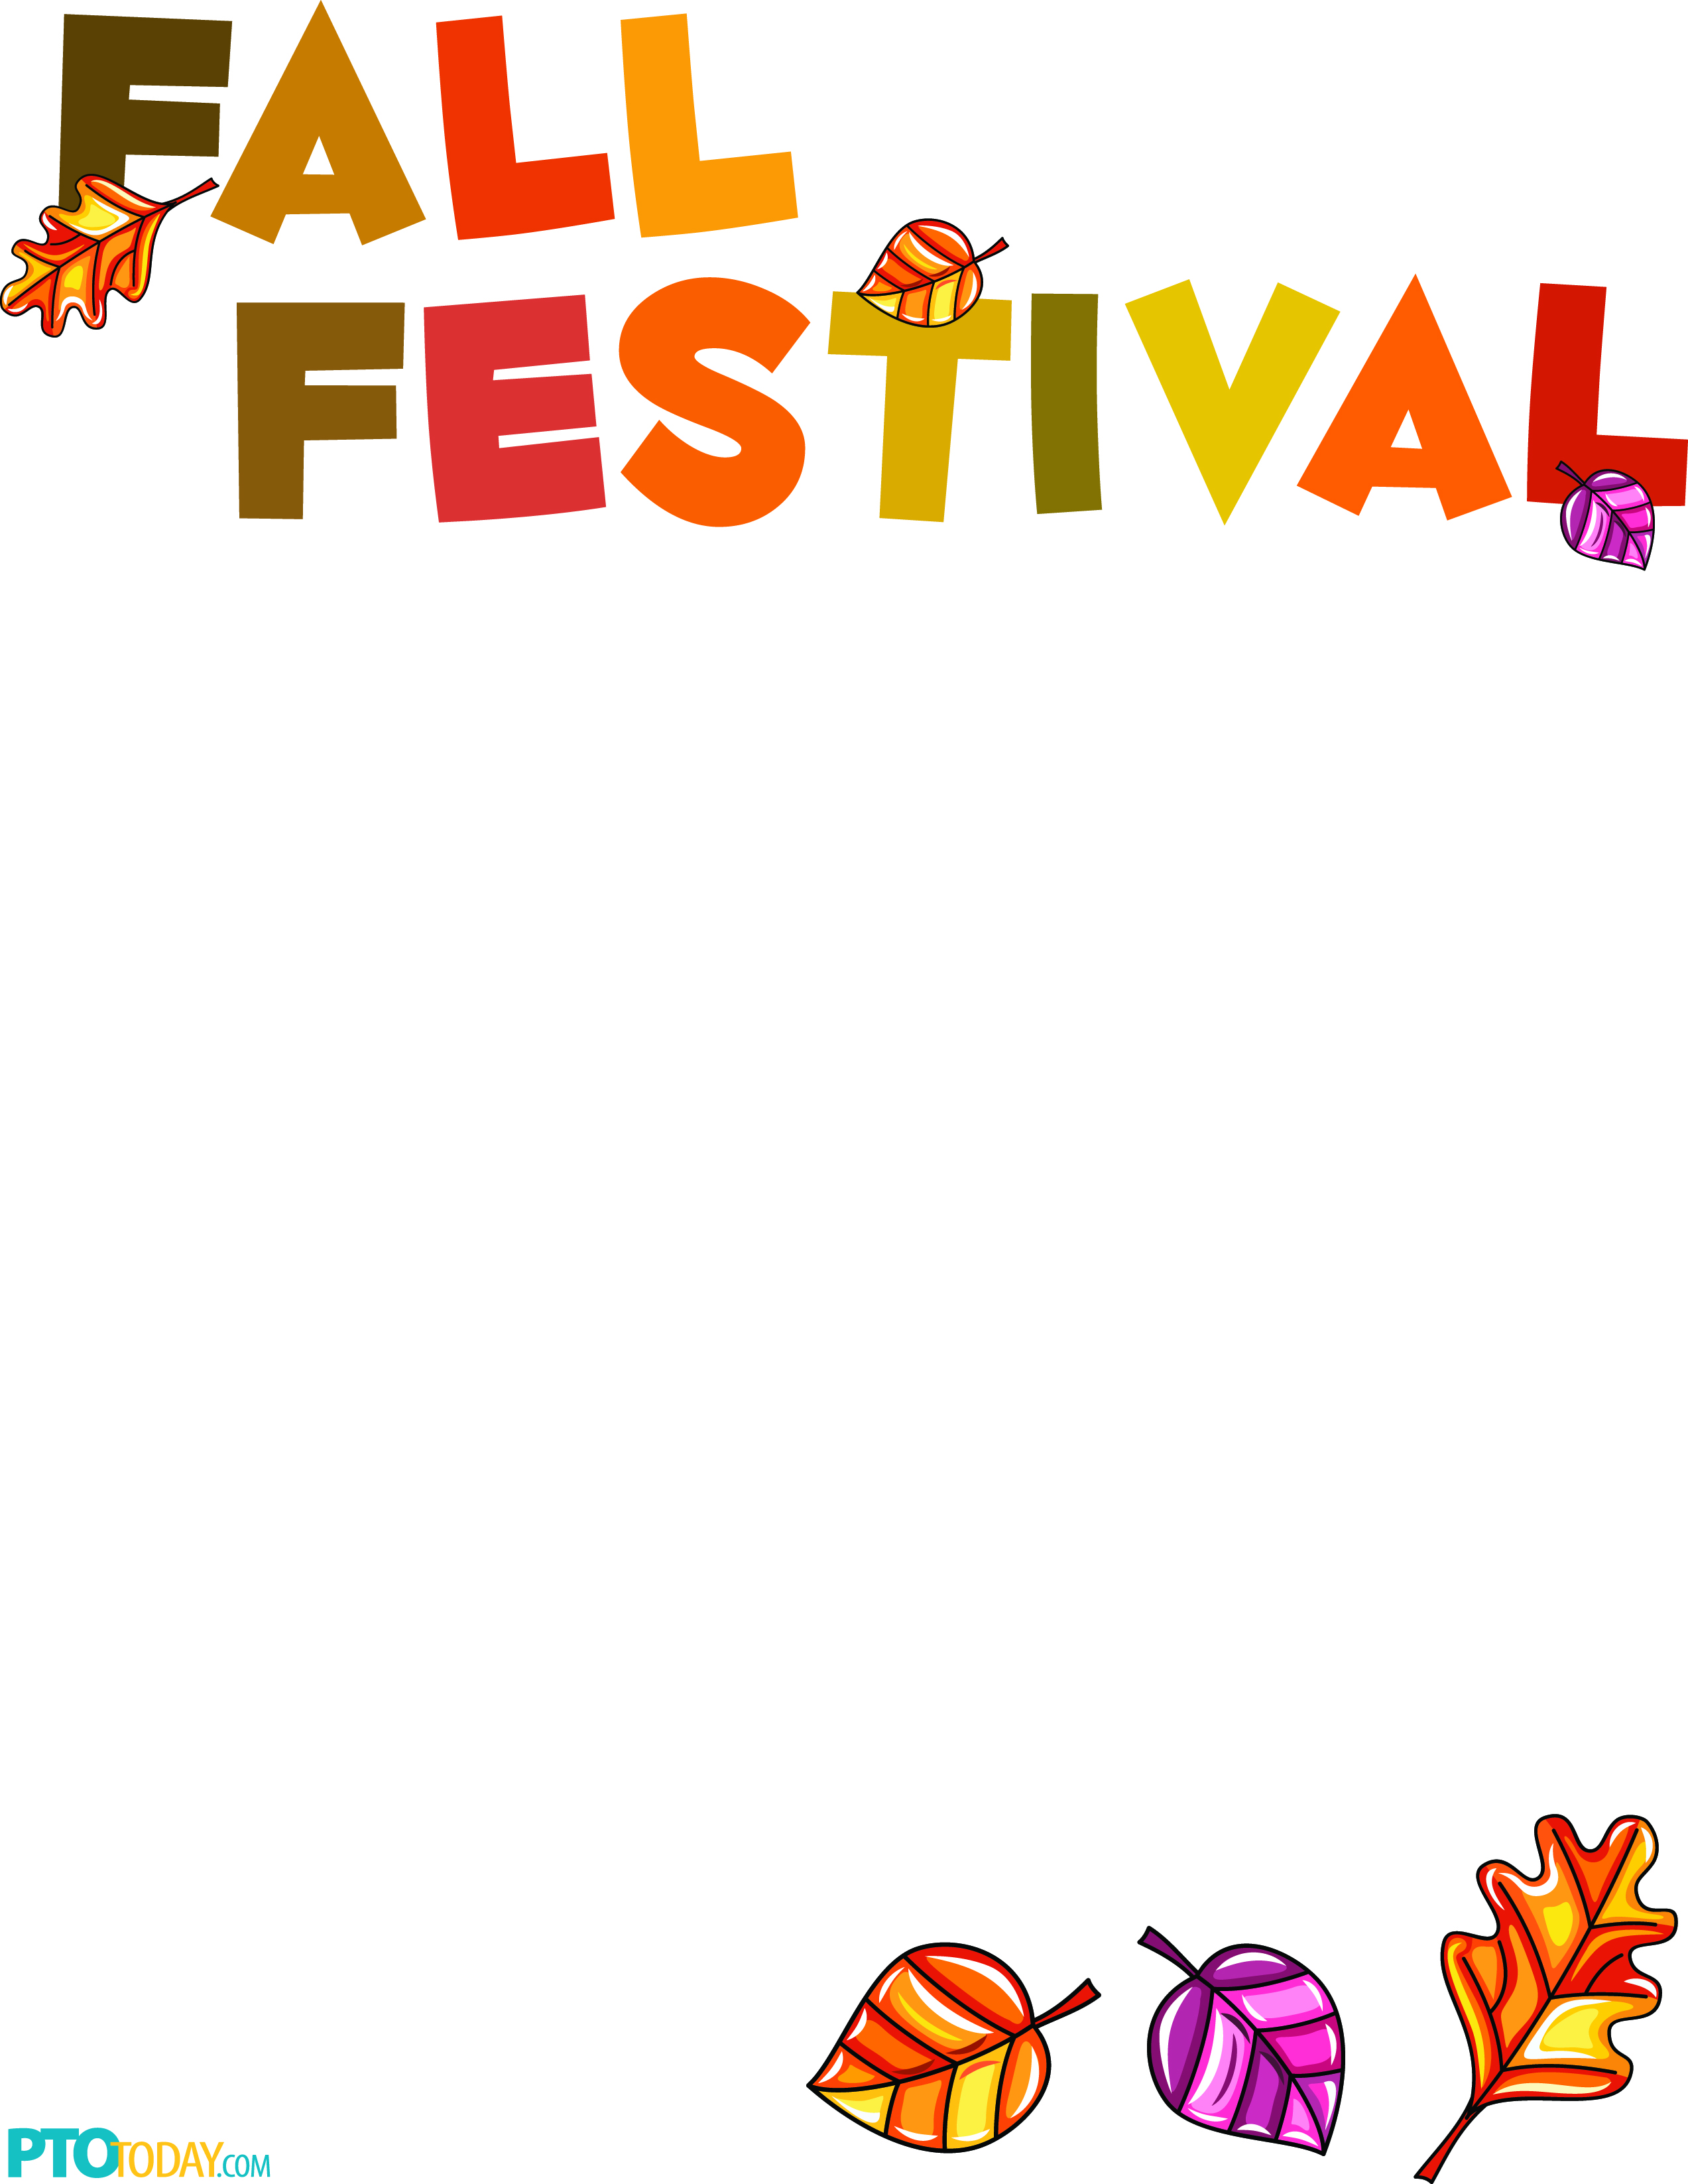

**The whole family is invited! Join us!**

**When:** Friday, November 9th   
**Time:** 4:30 p.m.- 6:30 p.m.  
**Where:** Cedarcrest-Southmoor Elementary

**Booths will include:**

* Cake Walk, Pumpkin Spice Slime Booth, Human Board Game, Silicone Bracelets, Face Painting, Football Toss, Penny Toss, and Much More!

**Food will include:**

* Pickles, Popcorn Balls, Hot dogs, Nachos, Chips, Ice Cream, Juice, and Soft Drinks

**Tickets are $1.00 each!**

**Book Fair will be open!**

*Put on by Cedarcrest-Southmoor PTO*